User Guide - PAC | Permanent access request
Action | System Reaction
Log on to lift portal | The user is presented with the welcome page
Click on the operations Icon   | The Operations Self Service is displayed with a list of services in the left hand column  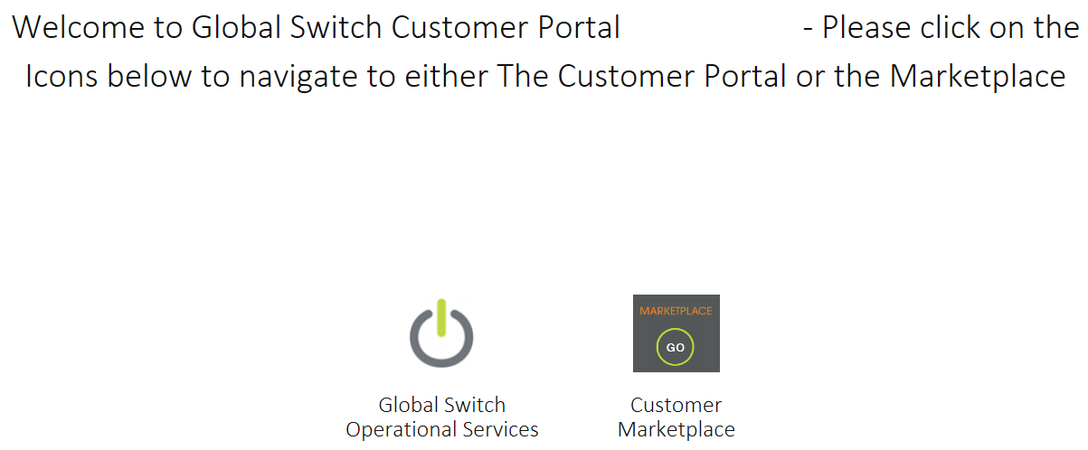
From the list of services select “Access Services”.  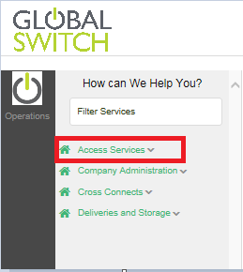 | The selection expands to offer list of choices.  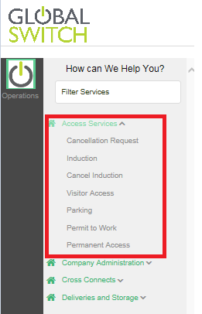
Select Permanent access  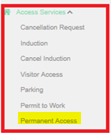 | Permanent access landing page is displayed.  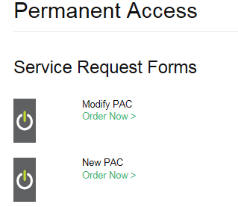
Under heading new PAC select "order now" | A blank permanent access form appears
Select the person for whom the card is requested (the card holder) from the list of inducted persons the system provided. This can be achieved via predictive text or the search icon. | The box will populate with the users name.  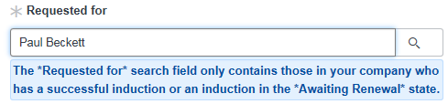
Press Select location | A reduced list will appear displaying relevant locations where the users company has leased space from Global Switch.  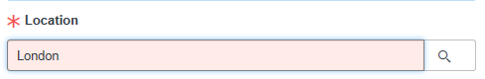
Select areas of access, double click on desired areas to move from left to right side.  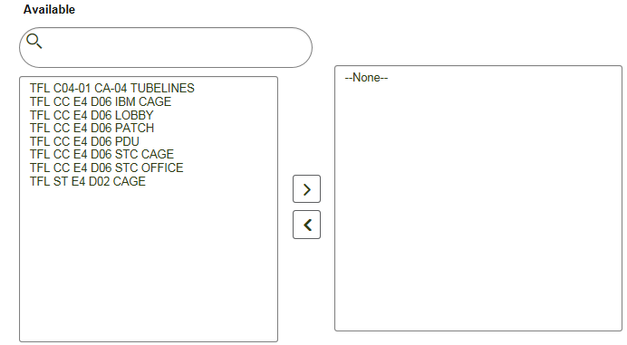 | A reduced list will appear displaying relevant locations only which the card holder has passed inductions for.
Choose from the choice field if you want the PAC to expire when the holders induction expires  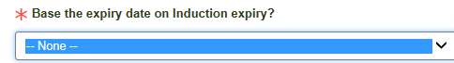 | System offers two choices:- (mandatory field)  YES - if selected the card remains active all the time the holder maintains an active induction.  NO - An additional field will appear requesting a fixed date on which the PAC will expire.  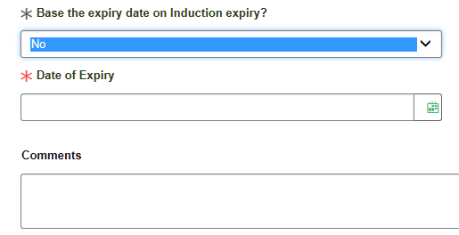
Continued,
Action | System Reaction
Complete optional comments field if needed | Comments will be retained for future reference.
Hit submit button   | The system will respond by returning an on screen message that confirms the request with a unique number that corresponds to the request.  If customer has PAC available status of the request will become awaiting collection, at this point two emails are sent, one to security and one to the requester and the request can be seen in the security PAC inbox awaiting fulfilment.  if no PAC's are available an email request goes out to Global Switch commercial Admin to request quote and request status is set to awaiting quote. An email is also sent to the requester and the request is routed to the commercial admin inbox.

